**World History: The Middle Ages** – The Crusades: HELP WANTED! Page: ____________ Date: ______________

C:\Users\Tim J\AppData\Local\Microsoft\Windows\Temporary Internet Files\Content.IE5\D2PG4B2R\MC900434711[1].wmf*EQ: Why did people join the Crusades? What were their motives?*

Directions: Use the text passages to answer the questions that follow. Then,   
create an advertisement trying to get Europeans to join the Crusades.

**Document 1. 1095, Pope Urban II.**

“"Although, O sons of God, you have promised more firmly than ever to keep the peace among yourselves and to preserve the rights of the church, there remains still an important work for you to do. . . . For your brethren who live in the east are in urgent need of your help, and you must hasten to give them the aid which has often been promised them. For, as the most of you have heard, the Turks and Arabs have attacked them and have conquered the territory of Romania [the Byzantine Empire]. . . . An accursed race has violently invaded the lands of the Christians. They have destroyed the churches of God or taken them for their own religion. Jerusalem is now held captive by the enemies of Christ, subject to those who do not know God – the worship of the heathen….. He who makes this holy pilgrimage shall wear the sign of the cross of the Lord on his forehead or on his breast….. If you are killed your sins will be pardoned….let those who have been fighting against their own brothers now fight lawfully against the barbarians…. “

**Document 2. A French crusader writes to his wife, 1098.**

My dear wife, I now have twice as much silver, gold and other riches as I had when I set off on this crusade……..

**Document 3. A French crusader writes to his wife, 1190*.***

Alas, my darling! It breaks my heart to leave you, but I must go to the Holy land. This is where I will win paradise and praise and your true love….

[1] Read the above extracts. Make a list of all the reasons you can find to explain why people went on a Crusade. Were all the reasons related to religion?

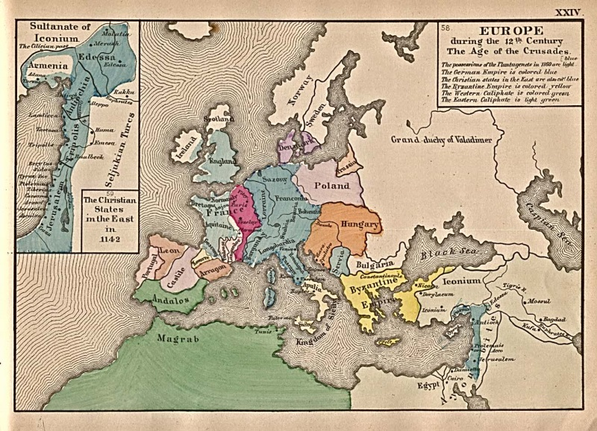[2] Can you think of any difficulties facing people on the way to a Crusade? Use the below map of the world in the 12th Century and discover how the Crusader armies would have reached the Holy Land.

**Document 4. The Words of Saladin**   
"If God blesses us by enabling us to drive His enemies out of Jerusalem, how fortunate and happy we would be! For Jerusalem has been controlled by the enemy for ninety-one years, during which time God has received nothing from us here in the way of adoration. At the same time, the zeal of the Muslim rulers to deliver it languished. Time passed, and so did many [in different] generations, while the Franks succeeded in rooting themselves strongly there. Now God has reserved the merit of its recovery for one house, the house of the sons of Ayyub [Saladin's family], in order to unite all hearts in appreciation of its members."

[1] What reasons does the Pope give for fighting for Jerusalem (Document 1)? What arguments does he use to persuade his listeners to go on a Crusade?

[2] What reasons does Saladin give for retaking Jerusalem? What arguments does he use to inspire his listeners?

[3] What are the similarities and differences between the arguments the Pope (Document 1) and Saladin (Document 4) use to persuade their listeners?

[4] What impressions do these speeches give you about the Crusades? What ideas do the speeches give you about the purposes of the people who fought during the Crusades?

**\*\*\*FINAL ASSIGNMENT***:** You must create an advertisement that will convince Europeans to join in on the fighting in the Holy Lands. Your ad must:

* Include a catchy headline to attract readers [larger print] (5 pt)

YOUR AD HERE

* Refer to at least 3 reasons to join/ fight [Be sure to include the ultimate goal of the crusades as one of your reasons] (5 pt)
* Include a year (2 pt)
* Name the person who is recruiting them (5 pt)
* Incorporate at least two Crusades-related image (5 pt)
* Use the entire paper (1 pt)
* Use color (2 pt)