Name ___________________________________

River Valley Civilizations

Mesopotamia | Egypt
Impact of Geography:  Characteristics of Mesopotamian Civilization : | Impact of Geography:  Characteristics of Egyptian Civilization:
  Specialized Workers | Record Keeping (Writing) | Advanced Technology
  Advanced Cities | Complex Institutions (Government) | Complex Institutions (Religion)
  Specialized Workers | Record Keeping (Writing) | Advanced Technology
  Advanced Cities | Complex Institutions (Government) | Complex Institutions (Religion)
Class Notes on Mesopotamia | Class Notes on Egypt

India | China
Impact of Geography:  Characteristics of Indus River Valley Civilization: | Impact of Geography:  Characteristics of Chinese Civilization:
  Specialized Workers | Record Keeping (Writing) | Advanced Technology
  Advanced Cities | Complex Institutions (Government) | Complex Institutions (Religion)
  Specialized Workers | Record Keeping (Writing) | Advanced Technology
  Advanced Cities | Complex Institutions (Government) | Complex Institutions (Religion)
Class Notes on India | Class Notes on China

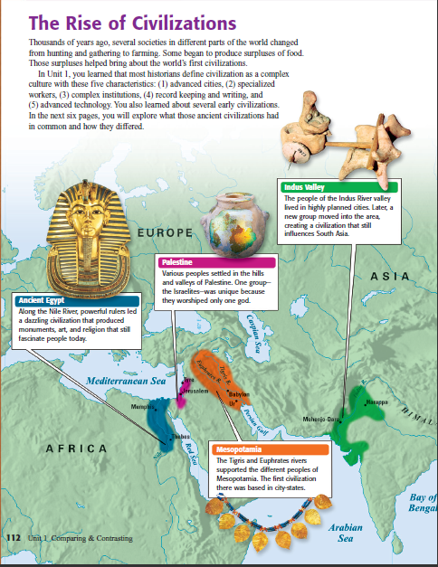
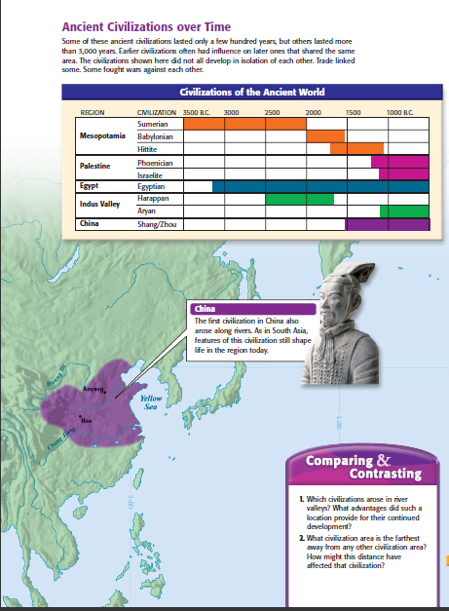

Teacher Guide (Answer Key?)



