Roman Empire Guided Notes
Roman Expansion
- By the 3rd century B.C., the Romans conquered the ___________________________ peninsula & began to exert power in the Mediterranean world
  - But, the growth of Rome threatened ___________________________, the superpower of the Mediterranean world
    - In a series of battles known as the ________________________________, Rome defeated Carthage & began the dominant power in the Mediterranean
  - After the Punic Wars, Rome conquered new _____________________________ & gained great wealth
    - One of the generals who led Rome’s expansion was a politician named _____________________________________
Problems for the Roman Republic
- Rome’s expansion brought ___________________, but also created problems:
  - The addition of new lands & sources of slave labor increased the gap between the rich & poor
  - Generals who controlled the armies became more powerful than the politicians in the Senate
  - Struggles for power led to a series of civil wars in Rome
The Rise & Fall of Julius Caesar
- Julius Caesar took advantage of the ____________________ in Rome & was named dictator in 46 B.C.
- He initiated a series of ______________________________ that offered Roman citizenship to conquered people & created new jobs
- Many Senators feared Caesar’s popularity & power as ____________________________ of Rome
  - In 44 B.C., Senators ______________________________ Julius Caesar
Roman Civil War
- The assassination led to another civil war led by Caesar’s adopted nephew _____________________ & his best general, Marc Antony
End of the Republic and Rise of the Empire
- Caesar’s death changed Rome:
  - People no longer trusted the Senate to rule Rome & the Roman Republic came to an end & the empire began
- Octavian emerged as the _________________________ leader of Rome, was given the title Augustus (“Exalted One”), & became Rome’s first emperor
- Under Augustus, Rome was ruled as an empire; the _______________________ still met but the emperor had all the real power
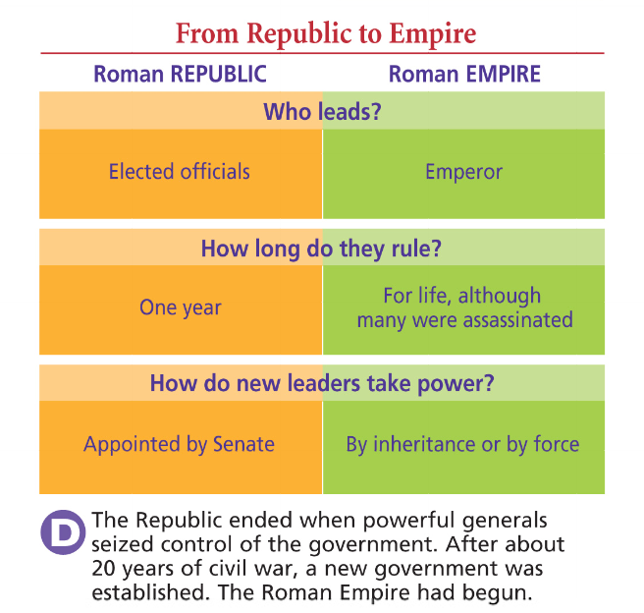

Pax Romana
- Augustus’ 41 year reign marked the beginning of a 207-year era of peace, wealth, & expansion known as the ____________________________________________ (“the Roman Peace”) from 27 B.C. to 180 A.D.
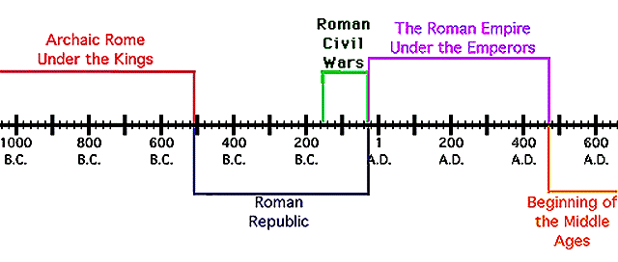

Pax Romana

- During the Pax Romana, the __________________________ expanded to its height & brought great wealth to Rome
  - The Pax Romana became the “______________________________” of Rome as emperors like Augustus built roads & a merit-based bureaucracy to rule the empire
Roman Architecture
- Roman architects used new styles like _____________________ & concrete to beautify cities
  - Emperors built arenas & used chariot races, gladiator events, & theater to ______________________ the poor
Conclusion
- Rome expanded from a _________________, to a republic, to an _________________________
  - The era of the Roman Republic introduced _____________________________ democracy
  - The era of the Roman Empire sparked the _________________________________ & the “golden age” of Roman innovation & culture

